**Detailed build guide**

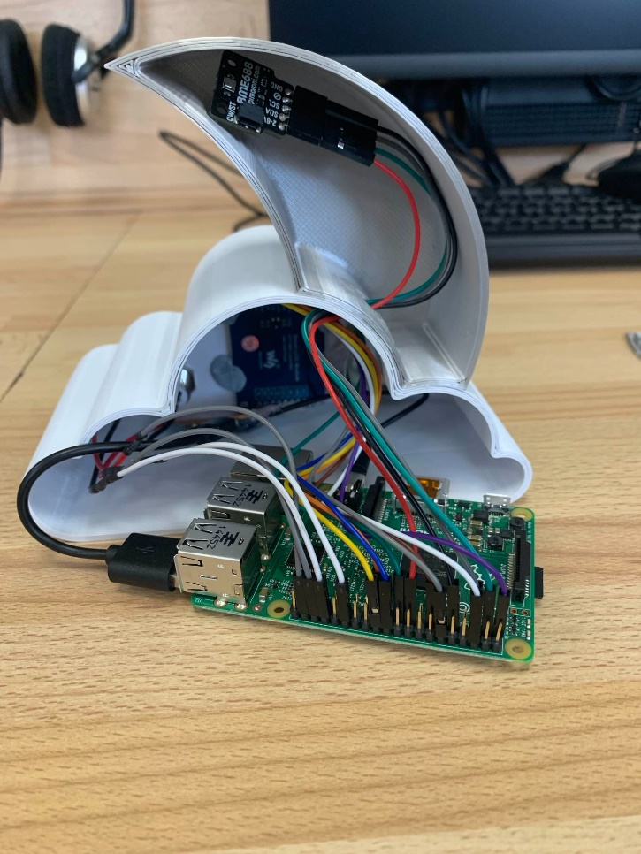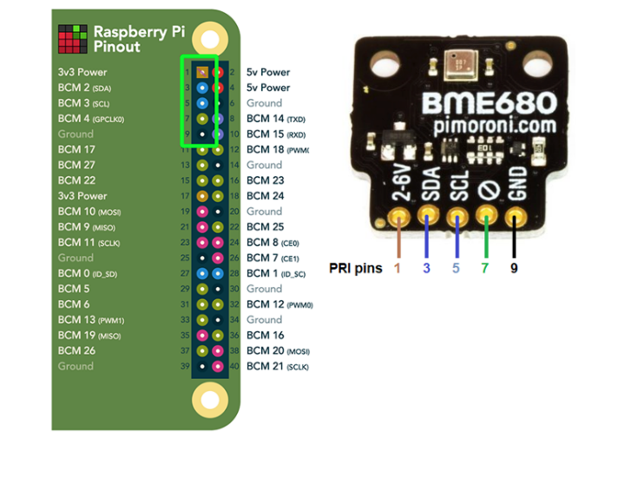

We wired up our air quality sensor to the raspberry pi using this photo on the top right. We used this photo to help us because we needed guided help on what to do so we got it all right. Then we fitted out sensor into the moon.

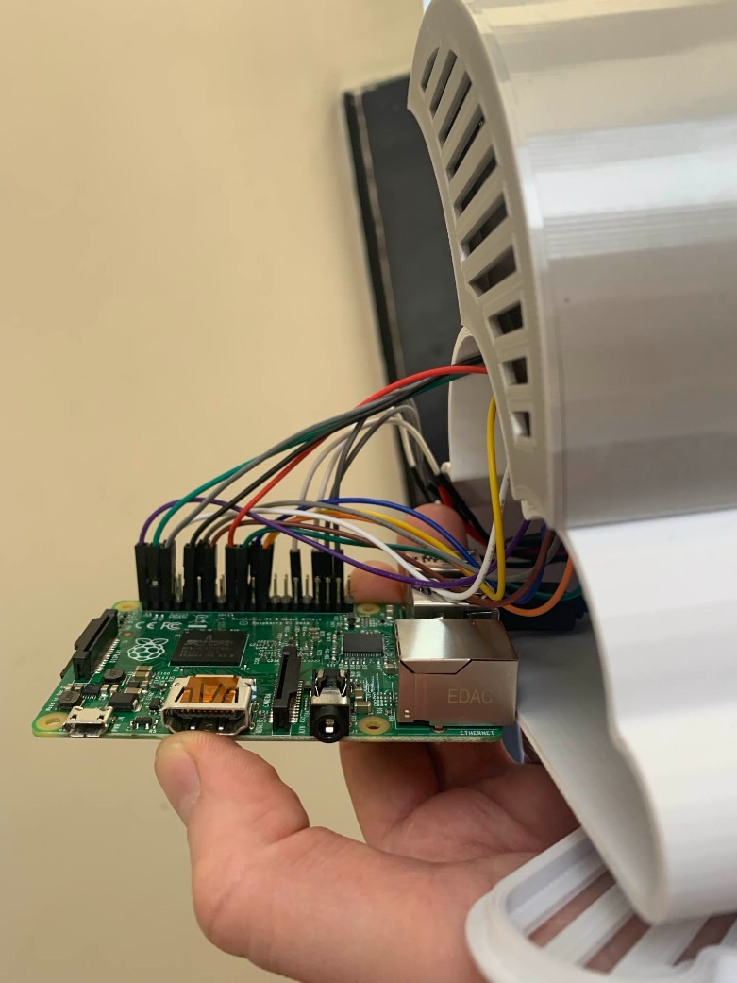

We also wired up our speaker and screen onto the pi.

